Lisa Scott
Consulting Division Practice Leader
lisas@heffins.com

POWERED BY GOTSAFETY.COM
IN PROUD PARTNERSHIP WITH GOTSAFETY
YOUR RISK MANAGEMENT & SAFETY SOLUTION

GotSafety Client Center and Mobile App

- Access to over 1,200 bilingual safety lessons, with an average of 30 new ones each month.
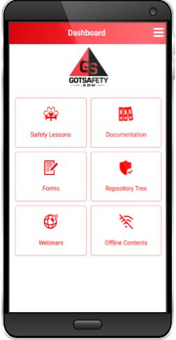
- Off-line Content: download items into your off-line content and never miss a training or electronic form again, no matter where you are.
- Digital Signature Capture: employees can sign-off on their training with their finger on a mobile device or mouse on a desktop.
- Request a lesson or video: If we don’t have the lessons you need, please let us know and we will produce it for you at no extra cost!
- Free Safety and Risk Consultation
- Unlimited Technical and Customer Support
- Manage employee roster – upload, activate, and deactivate employees
- Approve newly added lessons for viewing
- Create custom playlist for new hires, departments etc.
- Schedule employee training
- Document Upload – Upload company documents such as Safety Data Sheets, PDFs, and more.

ONSITE INSPECTIONS (only available in CA, NV, AZ & UT)
We provide comprehensive on-site inspections, performed by experienced and well-qualified safety inspectors. Your inspection can include the following elements:

On-site Visit and Walk-through of your Facility
- Review of your safety program
- Review of your training programs
- On-the-spot consultation to:
- Correct or abate hazards
- Improve safety operations
- Maintain ongoing compliance
- Identification of possible hazards
- Identification of machine guarding hazards
- Summary of evaluation report, including:
- Photos, tied to OSHA regulations
- Instructions to abate/correct identified hazards
ONSITE TRAINING (only available in CA, NV, AZ & UT)

OSHA Requires that every company provide their employees with regular safety lessons. As an ongoing client, you will receive these mandatory lesson materials and expert support to maintain your safety training program. On-site lessons will be delivered by a qualified and experienced safety trainer. Your training can include the following elements:
- Lessons delivered in English or Spanish
- Safety Tailgate Meeting Materials
- Over 1,200 safety topics available
- Management Responsibility Lessons
- Workplace Hazard Identification Procedure

Specialized Training (ONLY AVAILABLE IN CA, NV, AZ, & UT)

*On-site Forklift Operator Certification - PLEASE CALL FOR PRICING
*On-site Cherry Picker Certification - PLEASE CALL FOR PRICING
*On-site Scissor Lift Certification - PLEASE CALL FOR PRICING
*On-site Boom Lift Certification - PLEASE CALL FOR PRICING
*On-site Respirator Training (fit-and-smell testing) - PLEASE CALL FOR PRICING
*On-site Forklift Train-the-Trainer Certification - PLEASE CALL FOR PRICING
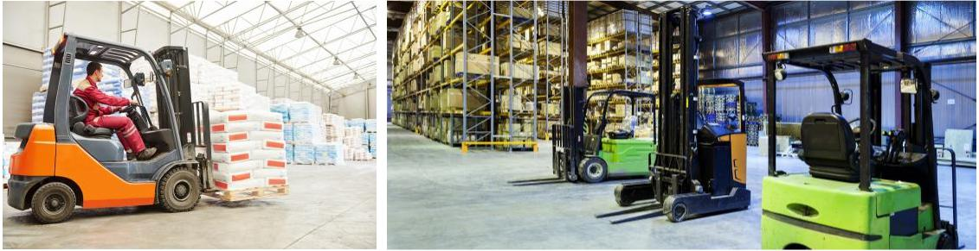
OSHA Documentation Creation
Your documentation will be written exclusively for your company and your industry. Your documentation will also address the general types of equipment you may use, the types of hazards your employees are exposed to, how to identify hazards, what to do in case of certain types of injuries, and how to avoid them. We will keep your safety programs current with OSHA regulations for the life of your account.
You will have access to all of your customized documentation online at www.GotSafety.com.
We will write and update all documentation listed below as needed.

- Infectious Disease & Response Plan
- COVID-19 Prevention Plan
- Emergency Action Plan
- Accident/Incident Investigation
- Fire Protection and Prevention Plan
- Injury and Illness Prevention Program (IIPP)
- Heat Illness
- Bloodborne Pathogens
- Confined Space
- Energy Control (Lockout/Tagout)
- Fall Protection
- Hot Work
- Noise Exposure & Hearing Protection
- Personal Protective Equipment
- Powered Industrial Truck
- Respiratory Protection
- Scaffold Safety
- Crane Operation Safety
- Airborne Contaminants
- Aerial Devices and Elevating Work Platforms
- Asbestos
- Lead
- Aerosol Transmissible Diseases
- HAZWOPER
- Roofing Safety
- Methylenedianiline (MDA)
- Hazard Communication
- Repetitive Motion and more...

